**VISVESVARAYA TECHNOLOGICAL UNIVERSITY**

**‘JNANA SANGAMA’ BELAGAVI-590 014, KARNATAKA**



**A Mini-Project Report**

**ON**

**“PACMAN GAME”**

**SUBMITTED IN PARTIAL FULFILLMENT OF THE REQUIREMENT**

**for the 6 Semester BE, CG Mini-Project-17CSL58,**

**2020**

**Submitted By**

1. **MAHESH A.C**

**[1CG17CS049]**

1. **CHETAN M**

**[1CG17CS016]**

**Under the guidence of: HOD:**

**Mr. Mahesh N, M.Tech, Dr. Shantala C.P, Ph.D,**

Asst. Prof. Dept of CSE, Prof & Head, Dept of CSE,

CIT, Gubbi, Tumkur. CIT, Gubbi, Tumkur.

** **Channabasaveshwara Institute of Technology**

(Affiliated to VTU, Belgaum & Approved by AICTE, New Delhi)

(**NAAC Accredited & ISO 9001:2015 Certified Institution)**

NH 206 (B.H. Road), Gubbi, Tumkur – 572 216. Karnataka.

** Channabasaveshwara Institute of Technology** (Affiliated to VTU, Belgaum & Approved by AICTE, New Delhi)

(NAAC Accredited & ISO 9001:2015 Certified Institution)

N.H.206(B.H. Road), Gubbi-Tumakuru-572216, Karnataka

**DEPARTMENT OF COMPUTER SCIENCE ENGINEERING**

**CERTIFICATE**

This is to certify that the project work entitled **“MOVIE DATABASE MANAGEMENT SYSTEM”** has been successfully carried out by **MAHESH A.C [1CG17CS049], HARSHITHA GOWDA.K.L [1CG15CS032],** bonafide students of **CHANNABASAVESHWARA INSTITUTE OF TECHNOLOGY, GUBBI, TUMAKURU,** under our supervision and guidance and submitted in partial fulfillment for the V Semester BE, DBMS Mini-project -17CSL58 by **Visvesvaraya Technological University, Belagavi** during the academic year of 2019– 2020. It is certified that all corrections/suggestions indicated for internal assessment have been incorporated in the report deposited in the departmental library. The Mini project report has been approved as it satisfies the academic requirements for the above said degree.

**Guide: H.O.D:**

**Mrs. Jyothi. K.S, M.Tech Dr. Shantala C.P, Ph.D**

Asst.prof. Dept of CSE, Prof.&Head,Dept of CSE

CIT, Gubbi, Tumkur. CIT, Gubbi, Tumkur.

**Principal: Examiners:**

1.

**Dr. Suresh D S, Ph.D**

CIT, Gubbi, Tumkur. 2.

Movie Database 2019-2020

**ACKNOWLEDGEMENT**

A great deal of time and lot of effort has gone into completing this mini project report and documenting it. The number of hours spent in getting through various books and other materials related to this topic chosen by me have reaffirmed its power and utility in doing this lab work.

Several special people have contributed significantly to this effort. First of all we are grateful to our institution **Channabasaveshwara Institute of Technology**, Gubbi, which provides us an opportunity in fulfilling our most cherished desire of reaching the goal.

We acknowledge and express our sincere thanks to our beloved Director and Principal  **Dr. Suresh D.S** for his many valuable suggestions and continued encouragement and support in the academic endeavors.

We wish to express our deep sense of gratitude to **Dr**. **Shantala C.P,** Prof. & Head, Dept of CSE, CIT, for all the guidance and who still remains a constant driving force and motivated through innovative ideas with tireless support and advice during the course of mini project to examine and helpful suggestions offered.

We express our sincere thanks to our guide **Mrs. Jyothi K.S,** Assistant Professor, Dept. of CSE, CIT, for his meticulous attention to details, which has contributed immeasurably to the quality of our project report.

Our sincere and hearty thanks to our beloved parents, friends and others for their all-time support and co-operation.

**PROJECT ASSOCIATES:**

**MAHESH A.C (1CG17CS049)**

**HARSHITHA GOWDA K.L (1CG17CS032)**

Movie Database 2019-2020

**ABSTRACT**

‘Movie Database’ system is a web application created for the purpose of viewing basic information about movies such as actor, producer, director, ratings etc. Besides displaying the ratings from popular websites such as IMDB and Rotten Tomatoes, PMDS allows user to rate the movies.

Lots of movies are produced every year, too many to watch all of them and in particular, to get an overview about the evolution of typical movie genres and actors playing in them. Moreover, it is a challenging problem to detect correlations among the movies and the actors in those movies, in particular, if we are interested in time-varying data patterns like trends, countertrends, or anomalies and outliers. Those correlations are specifically interesting if they can be inspected on different levels of granularity, e.g. temporal, but also hierarchical in form of country or continent-based correlations.

In this project we describe a web-based visualization that consists of major information views denoted by the movie cosmos and the career lines. Both views are linked and interactively manipulate while a list of user defined metrics are explorable. We illustrate the usefulness of the visualization by applying it to be the entire movie database.

**Contents**

|  |  |
| --- | --- |
| 1. Introduction | 1 |
| 1. System Analysis | 2 |
| 2.1 Proposed System | 2 |
| * + 1. Scope of the Project     2. Aim of the Project | 2  2 |
| 1. Requirement Specifications | 3 |
| 3.1 System requirements | 3 |
| * + 1. Hardware Configuration     2. Software Configuration | 3  3 |
| 3.2 Development Environment | 4-5 |
| 1. System Design | 6 |
| 4.1 ER Diagram | 6 |
| 4.2 Schema Diagram | 7 |
| 1. System Implementation | 8 |
| 5.1 Modules Description | 8-11 |
| 1. Sample Output Screenshots | 12-16 |
| 1. Conclusion | 17 |

Movie Database 2019-2020

Chapter 1

**INTRODUCTION**

Movies are the one of better way for entertainment for the world. The movies convey to people by audio as well as video effects, where maximum possibility of entertainment can be achived. Now a days people are more fond of new movies and make use of streaming webpages like Netflix, &flix, amazon prime movies etc.

Movies, also known as films, are a type of visual communication which uses moving pictures and sound to tell stories or inform (help people to learn). People in every part of the world watch movies as a type of entertainment , a way to have fun. For some people, fun movies can mean movies that make them laugh , while for others it can mean movies that make them cry, or feel afraid.

Normally a movie contains script with a very good story and narration. To develop a movie it as many fields like actors, directors, producers, camera team, etc. for maintaining the data of all the fields must be necessary for proper documentation helps to estimate the budget to produce and develop the movie. So we come across for developing and maintain the database this fields and many other.

The Movie database is one of the efficient management system which reduces the risk of human resource to manage the data. This database management system is software application to maintain activities of various fields in movie team during production and response of movies. This software helps to maintain data of actors, directors, movies, producers, ratings, etc…

When filming has finished , an editor puts the moving pictures together in away that tells the whole story within a set amount of time. Audio, video, pixels are joined it with the moving pictures. When the movie is done , many copies of the films are made by movie lab and get released in movie theatre. people give ratings to movies that’s also plays a major role for the industry and what was the profits gained for the movie, that data as more value now a days , to collect and maintain the data all the information is necessary that should be done by movie database management system.

Dept. of CSE,CIT,GUBBI page 1

Movie Database 2019-2020

**Chapter 2**

**SYSTEM ANALYSIS**

**2.1 Proposed System**

**2.1.1 Scope of the project**

The field of film making is highly competitive and has a lot of scope for employment opportunities, especially in India, which releases a large number of films every year. if one possesses artistic and technical skills and at the same time an ability to express ideas, this is the most appropriate field to work in.

All though there is no formal educational qualification required to enter this profession, it helps if you have enrolled in a film editing program as most of the well known institutes provide you with placement opportunities immediately after you finish your course which is really helpful as it gives your career in film editing a nice boost.

Being Imaginative and techno-servey are essential for this profession. You simply cannot become good video editor if you do not have flair for the creative you also need to have a sharp eye for detail, an analytical mind and the ability to work in a team.

**2.1.2 Aim of the project**

Films can have many different purpose depending on what we define a film as. Generally most feature films tends to do one are more of the following via story telling:

1.Manage the details of inserted data.

2.Data must be secure .

3.Altering the data if necessary .

4. Reduces the risk.

5. Handle the database and track records.

The reasons people make films are closely related to the purpose of films and why people watch films. First, movie making a profitable business and Hollywood knows it. Second, movie making is form of art and talented artists use to make creative difference in the world. third, there are other film makers whose films educate us about things we should know.

Dept. of CSE,CIT,GUBBI page 2

Movie Database 2019-2020

Chapter 3

**Requirement Specification**

**3.1 System requirements**

**3.1.1 Hardware configuration**

Hard configuration references the details and system resources setting allotted for a specific device. It is the important concept related to the software development, insufficient random access memory may affect adversely on the speed and efficiency of the whole system.

The processor should be powerful to handle the entire process.

1GB ram(min)

Either Intel core processor or AMD processor

250GB Space(min)

**3.1.2 Software Configuration**

The output of a software process is information that may be divided into three categories. a]Computer program (both source level and executable level), b]Work products that describes the computer program (targeted at both technical and end users), c]Data (contained within the program or external to it).

The items that comprise all information produced as part of software process are collectively called as software configuration. A major element in building the system is selection of the compatible software since the software in market experiencing in geometric progression selected software should be flexible to all system. This document gives the detailed description of the software requirement specification.

**Frontend-HTTP** Hypertext Transfer Protocol is an application protocol for distributed, collaborative, and hypermedia information systems. HTTP is the foundation of the data communication for the world wide web. Hypertext is structured text that uses logical links between nodes containing text. Development of HTTP was initiated by Tim Berners-Lee at CERN in 1989. A latest version of HTTP near future will become an RFC for HTTP version 2 protocol.

Dept. of CSE,CIT,GUBBI page 3

Movie Database 2019-2020

**Backend-MYSQL** is an open source relational database management system(RDBMS). The MYSQL development project as made its source code available under the terms of GNU, as well as under a variety of proprietary agreements. MSQL was owned and sponsored by a single for profit firm, the swidesh company MYSQL AB, now owned by oracle corporation for proprietary use, several paid edition are available, and offered additional functionality. MYSQL is central component of LAMP opens source web application software stack. LAMP is an acronym of “Linux, Apache, MYSQl, Perl/PHP/Phython”. MYSQL is also used in many high profile. Large-scale websites, including google, Facebook, Twitter, youtube.

Operating System Windows 10.

**3.2 Development environment**

XAMPP is free and open source cross-platform web server software, released under terms of Apache license 2.0. Apache is maintained by open community of developers under the aspire of Apache software foundation. In XAMPP, X stands for cross-platform, A stands for Apache, M stands for MariaDB, P stands for PHP, P stands for Perl.

Developer(s)-Apache Friends.

Initial release that may 22,2002

Stable release-7.1.11-Windows

*7.1.11-Linux

*7.1.11-macOS

Operating system-cross-platform

*Linux

*Windows

*solaris

XAMMP’s easy of development means a WAMP/LAMP stack can be installed quickly and simply on OS by a developer with the advantage that a number of common add-in application such as wordpress and joomal can also installed with similar tectnique of using Bitmani.

Dept. of CSE,CIT,GUBBI page 4

Movie Database 2019-2020

XAMPP also provides supports for creating and manipulating database in MariaDB and SQL lite its among others.

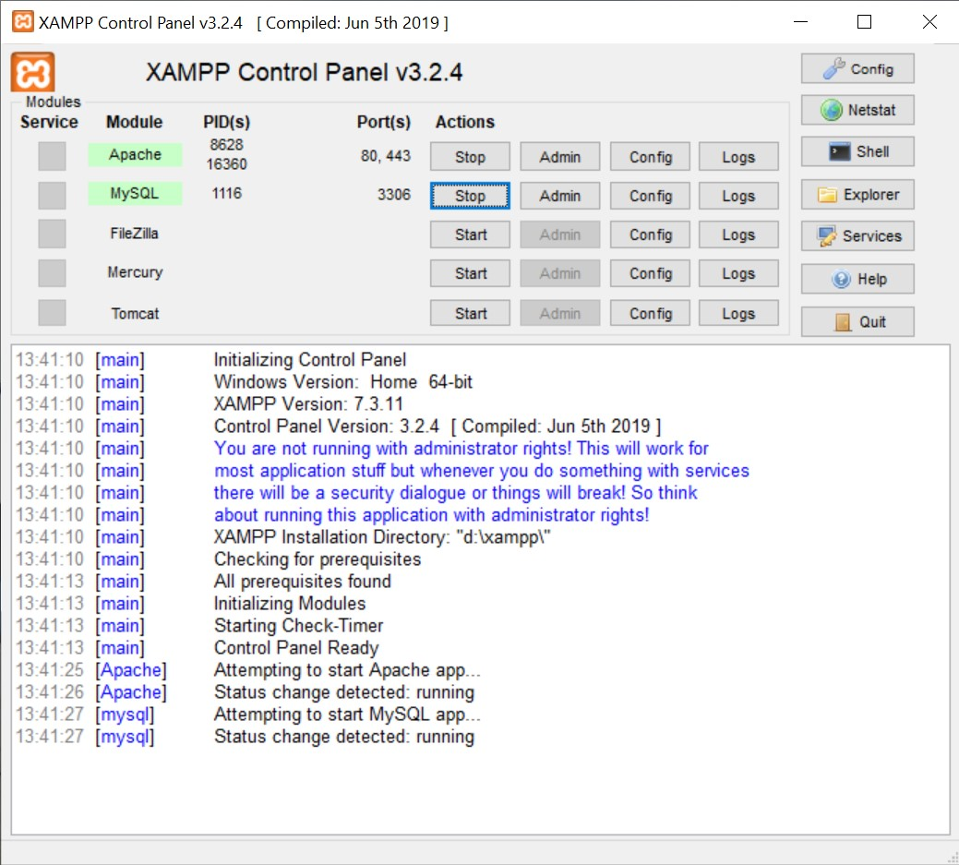

Dept. of CSE,CIT,GUBBI page 5

Movie Database 2019-2020

Chapter 4

**SYSTEM DESIGN**

**4.1 ER Diagram**

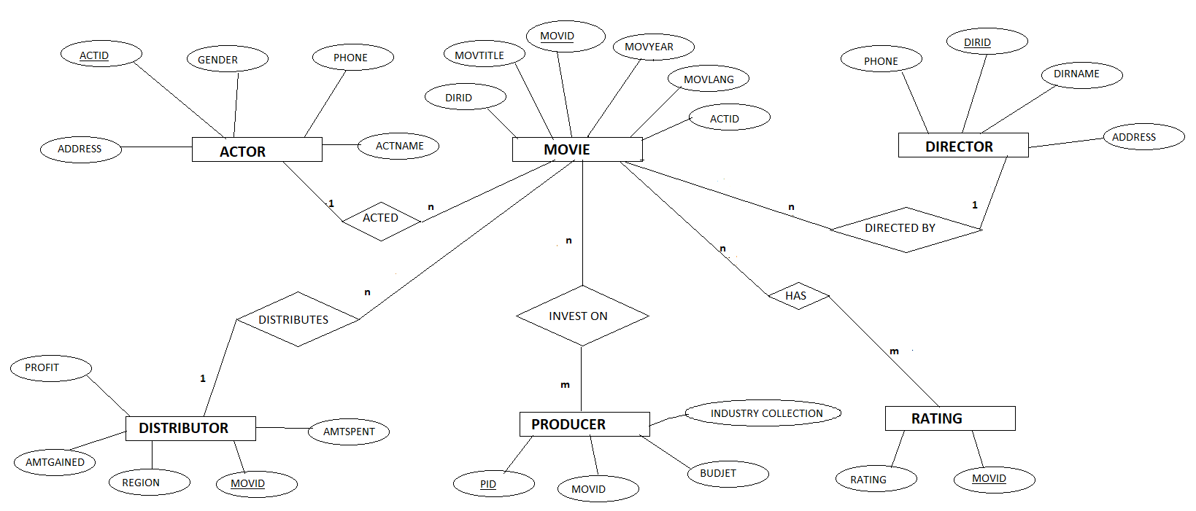

Fig 4.1 Diagram of movie database

Dept. of CSE,CIT,GUBBI page 6

Movie Database 2019-2020

**4.2 Schema Diagram**

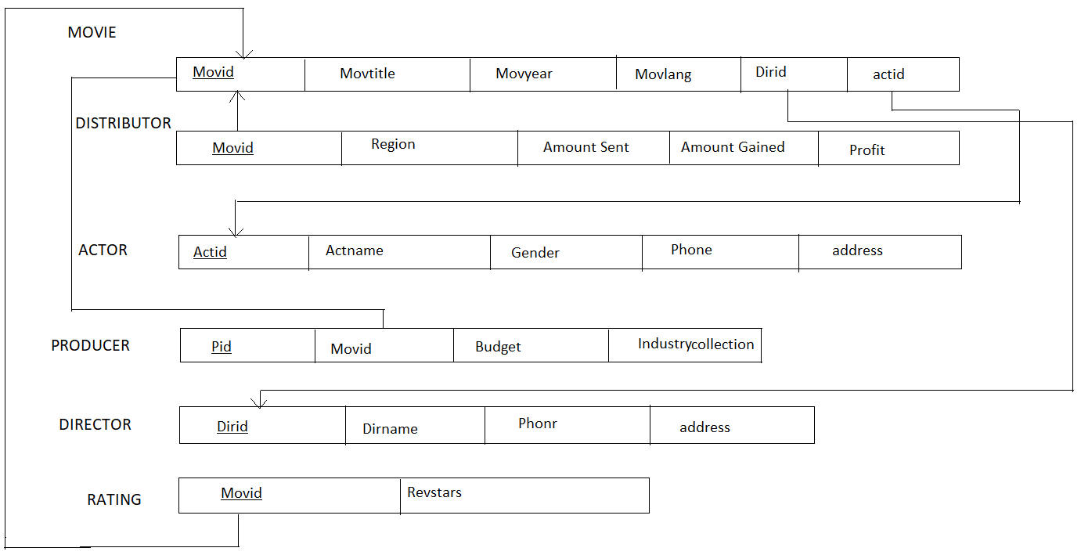

Fig 4.2 Schema Diagram of movie database

Dept. of CSE,CIT,GUBBI page 7

Movie Database 2019-2020

Chapter 5

**SYSTEM IMPLEMENTATION**

**5.1 Modules description**

\***Create**, create table statement is used to create table to store data. Integrity constraints like primary key, foreign key, unique key, can be defined while creating the table.

**Create code for every table**

**Actor table**

Create table Actor(

Actid int primary key,

actname varchar(15),

gender varchar(10),

phone varchar(10),

address varchar(15),

);

**Director table**

Create table director(

Dirid int primary key,

dirname varchar(15),

phone varchar(10),

address varchar(15),

);

**Distributor table**

Create table Distributor(

movid int primary key,

region varchar(10),

amountspent int,

amountgained int,

profit int,

foreign key(movid) references Movie(movid) on delete cascade);

Dept. of CSE,CIT,GUBBI page 8

Movie Database 2019-2020

**Movie table**

Create table Movie(

movid int primary key,

movtitle varchar(15),

movyear int,

movlang varchar(10),

dirid int,

actid int,

foreign key(dirid) references Director(dirid)on delete cascade,

foreign key(actid) references Actor(actid)on delete cascade);

**Producer table**

Create table producer(

Pid int primary key,

movid int,

budject int,

industrycollection int,

foreign key(movid) references Movie(movid)on delete cascade);

**Rating table**

Create table Rating(

movid int primary key,

revstars int,

foreign key(movid) references Movie(movid)on delete cascade);

Dept. of CSE,CIT,GUBBI page 9

Movie Database 2019-2020

**\*Insertion**, insertion is use to insert the tuple or row to the table. We insert value from fronted by making use HTTP the value inserted from to fronted will be going to store in backend database in XAMPPServer.

**Insertions codes for table**

**Actor table**

Insert into Actor values (‘&actid’, ’&actname’, ’&gender’, ’&phone’, ’&address’);

**\*Update**, update will help to edit the tables in the database. In this project we have given update option for table package, to update the place column in package table.

UPDATE Actor

SET phone=7019444092

WHERE actid=1;

**\*Delete,** delete will help us to delete a tuple or row from the table. In this project we have given delete option for table employee to delete the particular row or information from the table.

DELETE FROM Actor

WHERE actid=1;

\***Trigger,** a trigger is a special kind of stored procedure that automatically executes when an event occurs in the database server. DML events are INSERT, UPDATE, OR DELETE statements on a table or view.

In this project we have added trigger on package table to give discount of required percent on price.

**CODE:**

Set new.profit=(new.amountgained-new.amountspent)

Dept. of CSE,CIT,GUBBI page 10

Movie Database 2019-2020

**\*Stored procedure,** a stored procedure is a set of Structure Query Language(SQL) statements with an assigned name, which are stored in a relation database management system modify data in a database ,in this project we added stored procedure for table package to find income of our site.

**Code for stored procedure in SQL:**

SELECT SUM(industrycollection)INTO total_collection from producer;

**Code for stored procedure in PHP:**

$db_host=”localhost”;

$db_name=”movie”;

$db_user=”root”;

$db_pass=””;

$con=mysql_connect(“$db_host”,”$db_user”,”$db_pass”)or die (“could not connect”);

mysql_select_db(‘movie’)or die (mysql_error());

$p0=mysql_query(“call total_collection(@out); “);

$rs=mysql_query(‘SELECT@out’);

while($arr=mysql_fetch_row($rs));

{

echo ‘Total Industry Collection is=Rs. ‘.$arr[0];

}

mysql_close($dbh);

Dept. of CSE,CIT,GUBBI page 11

Movie Database 2019-2020

Chapter 6

**SCREENSHOTS**

**6.1 Welcome page:**

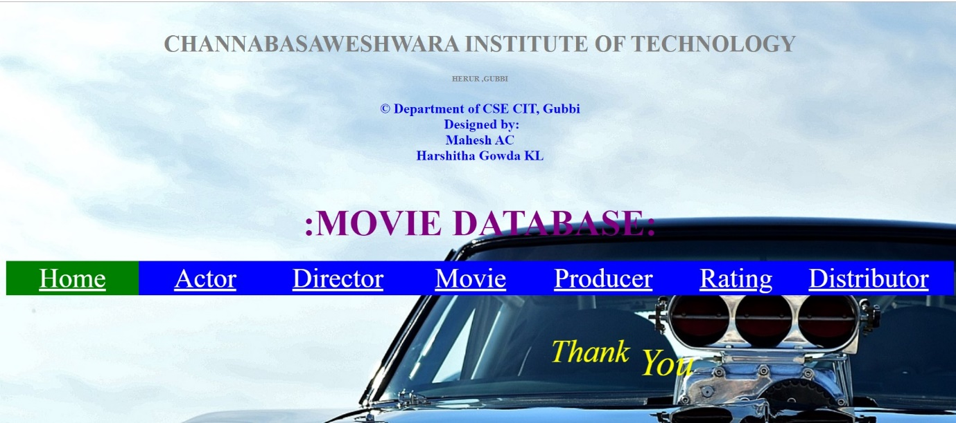

Fig6.1 welcome page

**6.2 Actor insertion**

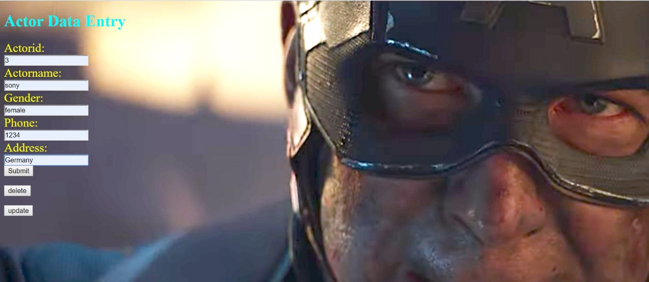

Fig 6.2 Actor insertion

Dept. of CSE,CIT,GUBBI page 12

Movie Database 2019-2020

**6.3 successful insertion**

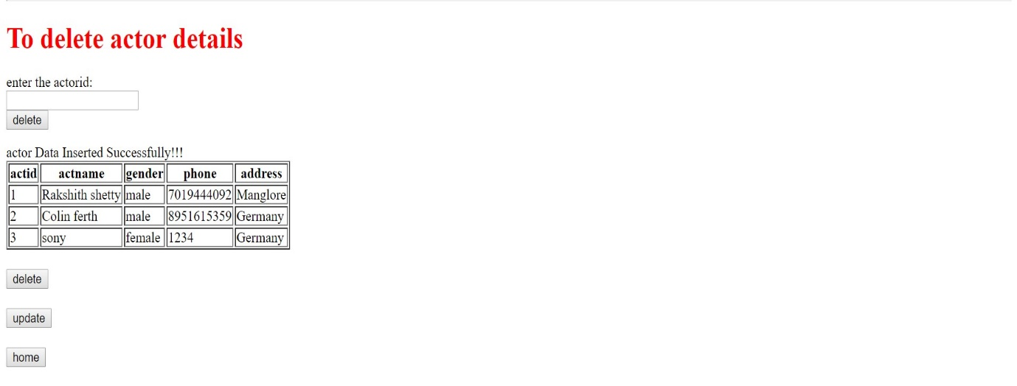

Fig 6.3 Actor details

**6.4 Update operation**

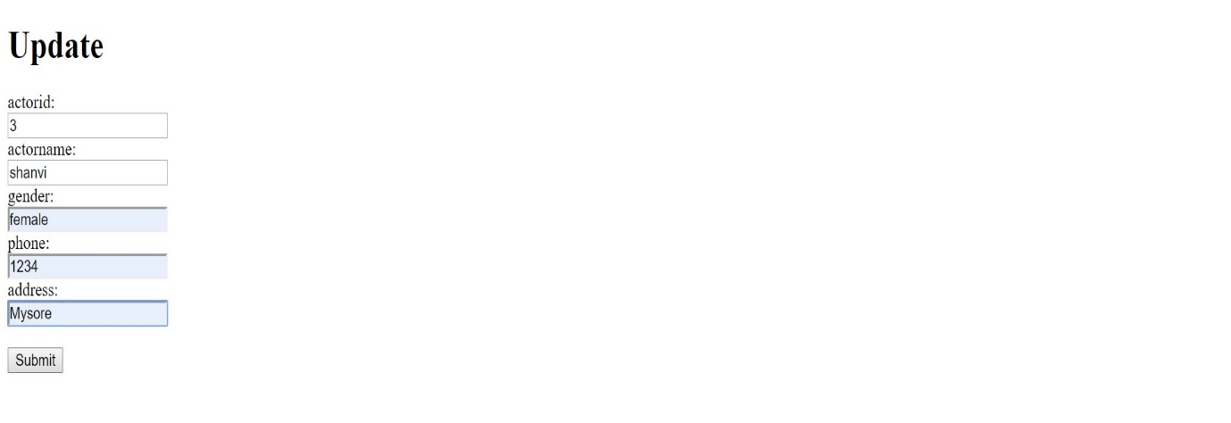

Fig 6.4 Update operation

Dept. of CSE,CIT,GUBBI page 13

Movie Database 2019-2020

**6.5 Successful update**

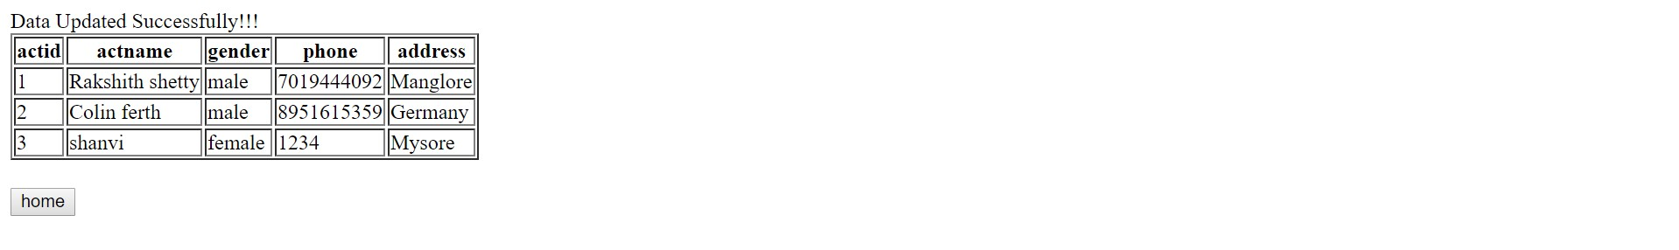

Fig 6.5 Display of successful update operation

**6.6 Delete operation**

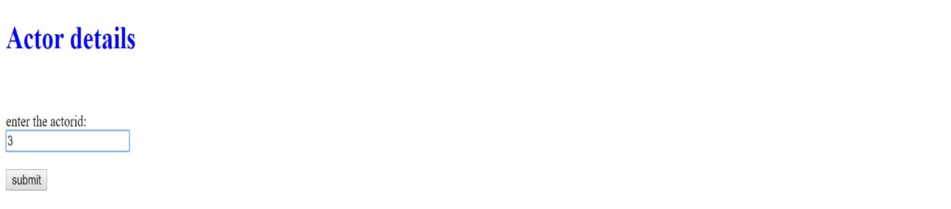

Fig 6.6 deletion operation

Dept. of CSE,CIT,GUBBI page 14

Movie Database 2019-2020

**6.7 Successful deletion**

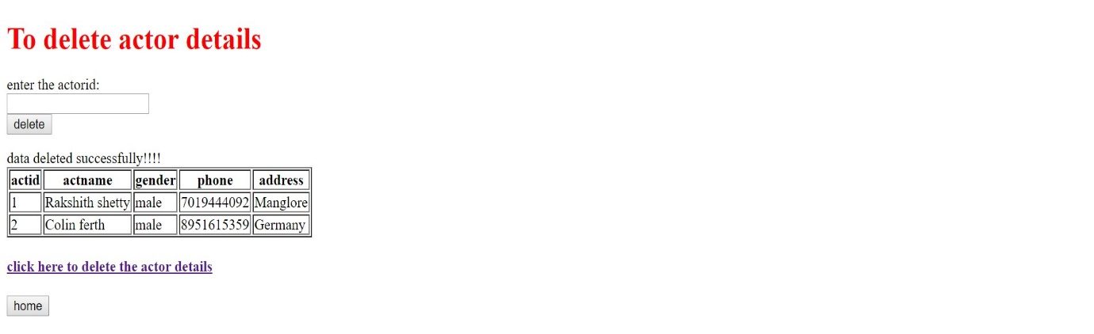

Fig 6.7 view of successful deletion

**6.8 Trigger**

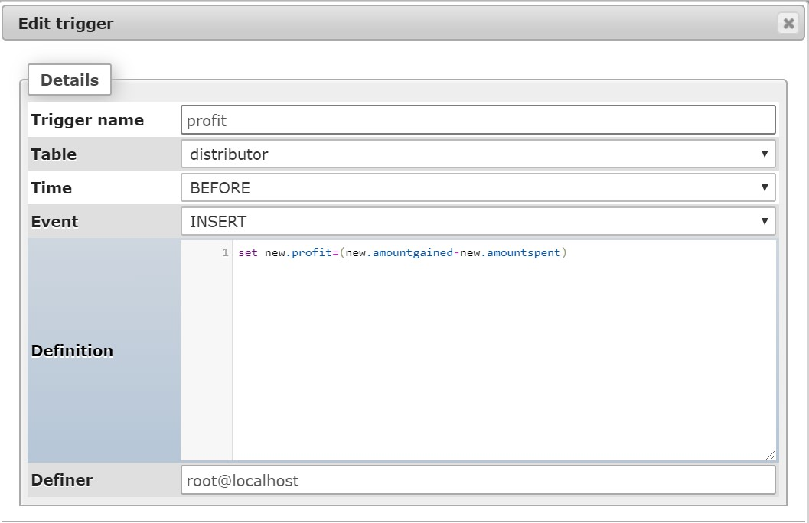

Fig 6.8 Trigger formula

Dept. of CSE,CIT,GUBBI page 14

Movie Database 2019-2020

**6.9 Stored procedure**

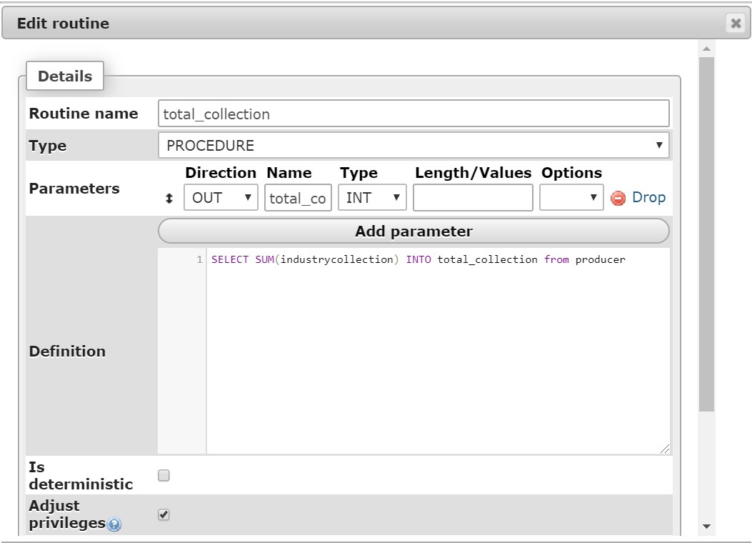

Fig 6.9 Stored procedure formula

**6.10 Stored procedure**

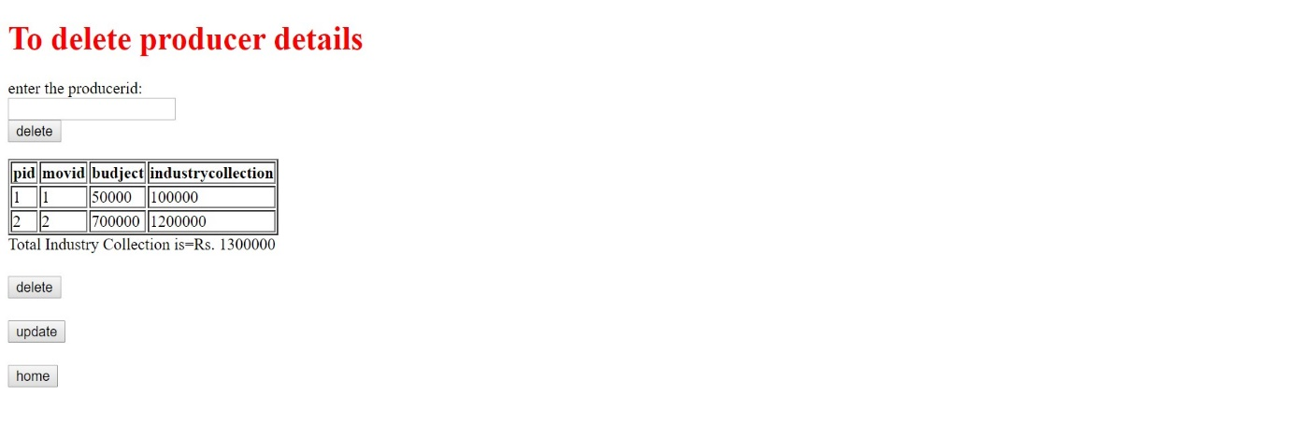

Fig 6.10 Stored procedure

Dept. of CSE,CIT,GUBBI page 15

Movie Database 2019-2020

**6.11 Trigger**

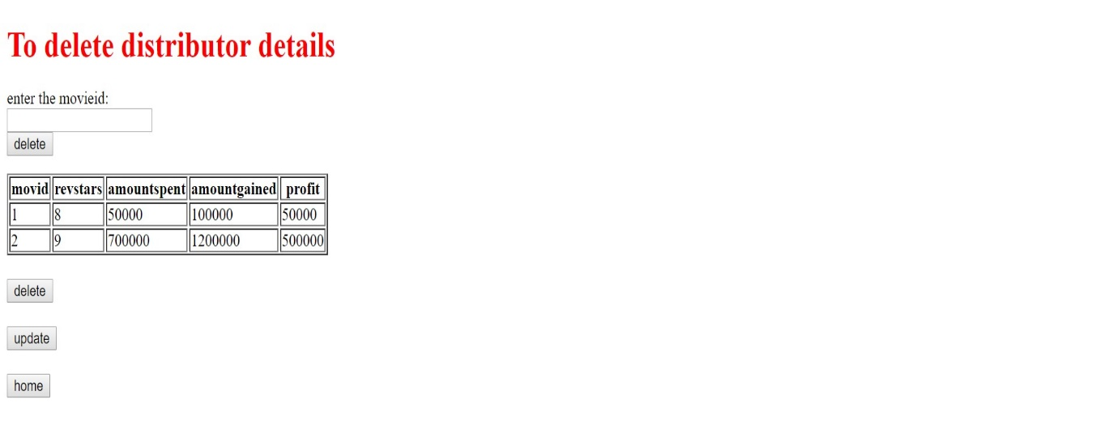

Fig 6.11 Trigger output

Dept. of CSE,CIT,GUBBI page 16

Movie Database 2019-2020

Chapter 7

**CONCLUSION**

There are always and there always be Two Sides of a Coin similarly, there are merits and demerits of films Many of you may not find advantages and disadvantages suiting to your personal opinion but that doesn’t lessen their gravity As pointed out in the above paragraphs the scale tips in the favor of disadvantages of movies Films do more harm than good and the good here cannot negate the bad, unlike in the movies It may sound strange and weird but it is true. And it doesn’t even mean that one should stop watching movies Watch only a few and forget the rest, there are much better things to do in life than spending time on overhyped and low-quality movies.

Some of the pros and cons of Films are evident; we can see them all around us. But the negative points are not easily perceived, remain unpublicized and are therefore lesser known the positive points of movies shine in front of us they are easily perceived, can be seen everywhere and the film industry itself publicizes it.

The underlining point is that watch only quality movies your decision in abstaining from cheap movies will have a positive effect on makers Porn anis violent films are popular because there is a demand if the demand ceases so will the supply The government also needs to take steps to discourage and eventually stop the production of movies which tend to corrupt. More importantly a compulsory short feature should be shown to educate the people of all ages about the truth and reality shown in the Movies.

Dept. of CSE,CIT,GUBBI page 17

Movie Database 2019-2020

**Bibliography**

It has been a matter of immense pleasure. Honor and challenge to have this opportunity to take up this project and complete it successfully.

We have obtained information from various resources to design and implement our project. We have acquired most of the knowledge from the Internet.

The following are some of the resources:

**\*** [www.w3schools.com](http://www.w3schools.com)

**\*** [www.github.com](http://www.github.com)

**\*** Stackoverflow

**\*** Google and Youtube.

Dept. of CSE,CIT,GUBBI page 18